Software design and implementation is the stage in the software engineering process at which an executable software system is developed.
* Software design and implementation activities are invariably inter-leaved.
* Software design is a creative activity in which you identify software components and their relationships, based on a customer’s requirements.
* Implementation is the process of realizing the design as a program.
An object-oriented design process
 Structured object-oriented design processes involve developing a number of different system models.
 They require a lot of effort for development and maintenance of these models and, for small systems, this may not be cost-effective.
 However, for large systems developed by different groups design models are an important communication mechanism.
Process stages
* There are a variety of different object-oriented design processes that depend on the organization using the process.
* Common activities in these processes include:
1. Define the context and modes of use of the system;
2. Design the system architecture;
3. Identify the principal system objects;
4. Develop design models;
5. Specify object interfaces.
* Process illustrated here using a design for a wilderness weather station. *
* Understanding the relationships between the software that is being designed and its external environment is essential for deciding how to provide the required system functionality and how to structure the system to communicate with its environment.
* Understanding of the context also lets you establish the boundaries of the system. Setting the system boundaries helps you decide what features are implemented in the system being designed and what features are in other associated systems.
* A system context model is a structural model that demonstrates the other systems in the environment of the system being developed.
* An interaction model is a dynamic model that shows how the system interacts with its environment as it is used.
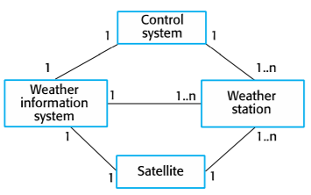System context
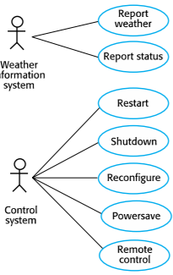Use cases
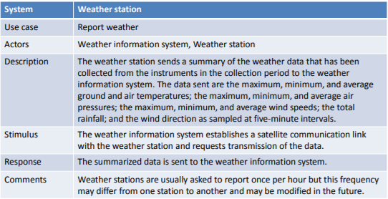Use case description
Architectural design
* Once interactions between the system and its environment have been understood, you use this information for designing the system architecture.
* You identify the major components that make up the system and their interactions, and then may organize the components using an architectural pattern such as a layered or client-server model.
* The weather station is composed of independent subsystems that communicate by broadcasting messages on a common infrastructure.
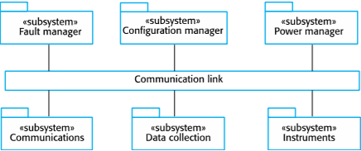High-level architecture
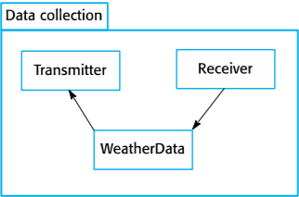Architecture of data collection system
Approaches to identification
 Use a grammatical approach based on a natural language description of the system.
 Base the identification on tangible things in the application domain.
 Use a behavioral approach and identify objects based on what participates in what behavior.
 Use a scenario-based analysis. The objects, attributes and methods in each scenario are identified.
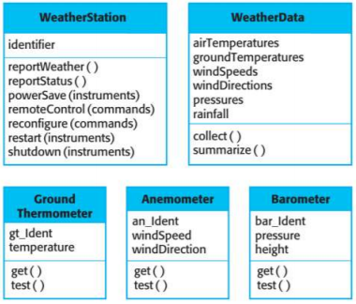Object classes
Design models show the objects and object classes and relationships between these entities.
 There are two kinds of design model:
1 Structural models describe the static structure of the system in terms of object classes and relationships.
2 Dynamic models describe the dynamic interactions between objects.
 Subsystem models that show logical groupings of objects into coherent subsystems.
- Shows how the design is organized into logically related groups of objects.
- In the UML, these are shown using packages – an encapsulation construct. This is a logical model. The actual organization of objects in the system may be different.
 Sequence models that show the sequence of object interactions.
- Objects are arranged horizontally across the top;
- Time is represented vertically so models are read top to bottom;
- Interactions are represented by labelled arrows, different styles of arrow = different types of interaction;
- A thin rectangle in an object lifeline represents the time when the
object is the controlling object in the system.
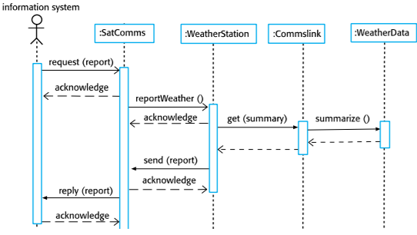
 State machine models that show how individual objects change their state in response to events.
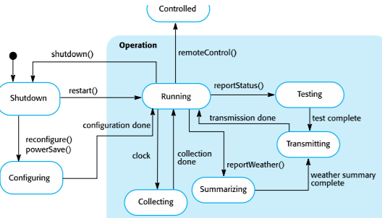
 Other models include use-case models, aggregation models, generalization models, etc.
Kinds of design patterns
1. Structural: relationships between entities
- E.g.: Façade, Decorator, Proxy, Data Access Object, Transfer
Object
2. Creational: instantiation mechanisms
- E.g.: Factory Method, Abstract Factory, Objectpool, Singleton
3. Behavioral: communications between entities
- E.g.: Iterator, Observer, Event Listener, Strategy
Pattern elements: Name, Problem description, Solution description, Consequences
Development platform tools
 An integrated compiler and syntax-directed editing system that allows you to create, edit and compile code.
 A language debugging system.
 Graphical editing tools, such as tools to edit UML models.
 Testing tools, such as Junit that can automatically run a set of tests on a new version of a program.
 Project support tools that help you organize the code for different development projects.
